Garment Retail Platform
Billing SaaS + Wholesale Discovery Marketplace
Product / Architecture Overview • Confluence Draft

1. Executive Overview
The product starts as a simple mobile-first billing and shop-management application for garment retailers. Once a meaningful retailer network is established, the platform expands into a B2B wholesale discovery marketplace where garment wholesalers can publish product photos and videos and retailers can discover new collections and directly connect with suppliers.

2. Product Vision
Build one digital platform that helps a garment retailer run the day-to-day shop and, over time, discover new wholesale products from suppliers.
- Retailer: Run the shop — billing, inventory, customers, credit and business insights.
- Retailer: Discover products — browse wholesale collections, videos and supplier catalogues.
- Supplier: Reach retailers — publish products, generate enquiries and receive direct leads.
- Platform: Improve discovery using appropriate, permissioned business signals.

3. Product Roadmap
Phase | Focus | Objective
Phase 1 | Retailer Billing SaaS | Acquire and retain garment retailers through daily-use workflows.
Phase 2 | Retailer Management | Add customers, Udhaar, analytics, WhatsApp and growth tools.
Phase 3 | Wholesale Discovery | Onboard wholesalers and expose their collections to retailers.
Phase 4 | Marketplace Growth | Add supplier analytics, promoted products and scalable monetization.

4. Phase 1 — Retailer App
Dashboard — Daily sales, bills, items sold, profit, credit and key indicators.
Billing / POS — Fast billing, size/colour selection, quantity, discount, GST, payment methods, invoices and reprint.
Products — Product catalogue with internal SKU/code, category, brand, MRP, selling price, cost, GST, size and colour variants.
Inventory — Current stock, size/colour stock, manual adjustments, stock history, low-stock alerts and valuation.
Customers — Profiles, purchase history, total spend, last purchase and notes.
Udhaar / Credit — Credit transactions, outstanding amount, partial/full payments, customer ledger and reminders.
WhatsApp — Invoices, payment reminders and later promotional messages.
Reports & Analytics — Sales, profit, product/category, inventory, customer and payment reports.
Offers & Promotions — Discount campaigns and customer communication.
Staff Management — Users, roles, permissions and staff-wise activity/sales.
Printing — 58/80mm thermal printing, PDF and sharing.
Initial exclusions: Purchase Management, Supplier Management inside POS, Barcode system, Returns & Exchanges.

5. Phase 2 — Wholesale Marketplace
After the billing product is stable and a retailer network exists, introduce a separate Wholesale Marketplace experience. The first marketplace version should focus on discovery and lead generation rather than complex checkout or logistics.

Retailer experience
- Wholesale feed with new arrivals.
- Photo and short-video product discovery.
- Wholesale price, MOQ, sizes, colours, category and supplier location.
- Supplier profile and catalogue.
- Save/favourite products.
- Call, WhatsApp or enquiry.
- Pre-filled enquiry to request catalogue/pricing.

Supplier experience
- Business profile.
- Product catalogue.
- Image/video product posts.
- Wholesale price and MOQ.
- Sizes, colours, categories and description.
- Retailer enquiries.
- Views, enquiries, WhatsApp clicks and calls analytics.
- Featured/promoted products in later phases.

6. Marketplace Discovery Model
The marketplace should feel closer to a professional wholesale product feed than a traditional B2B directory.
- New Arrivals
- Recommended for You
- Men's Wear
- Women's Wear
- Kids Wear
- Price/MOQ discovery
- Location-based discovery
- Supplier catalogues
- Featured products

7. High-Level Architecture
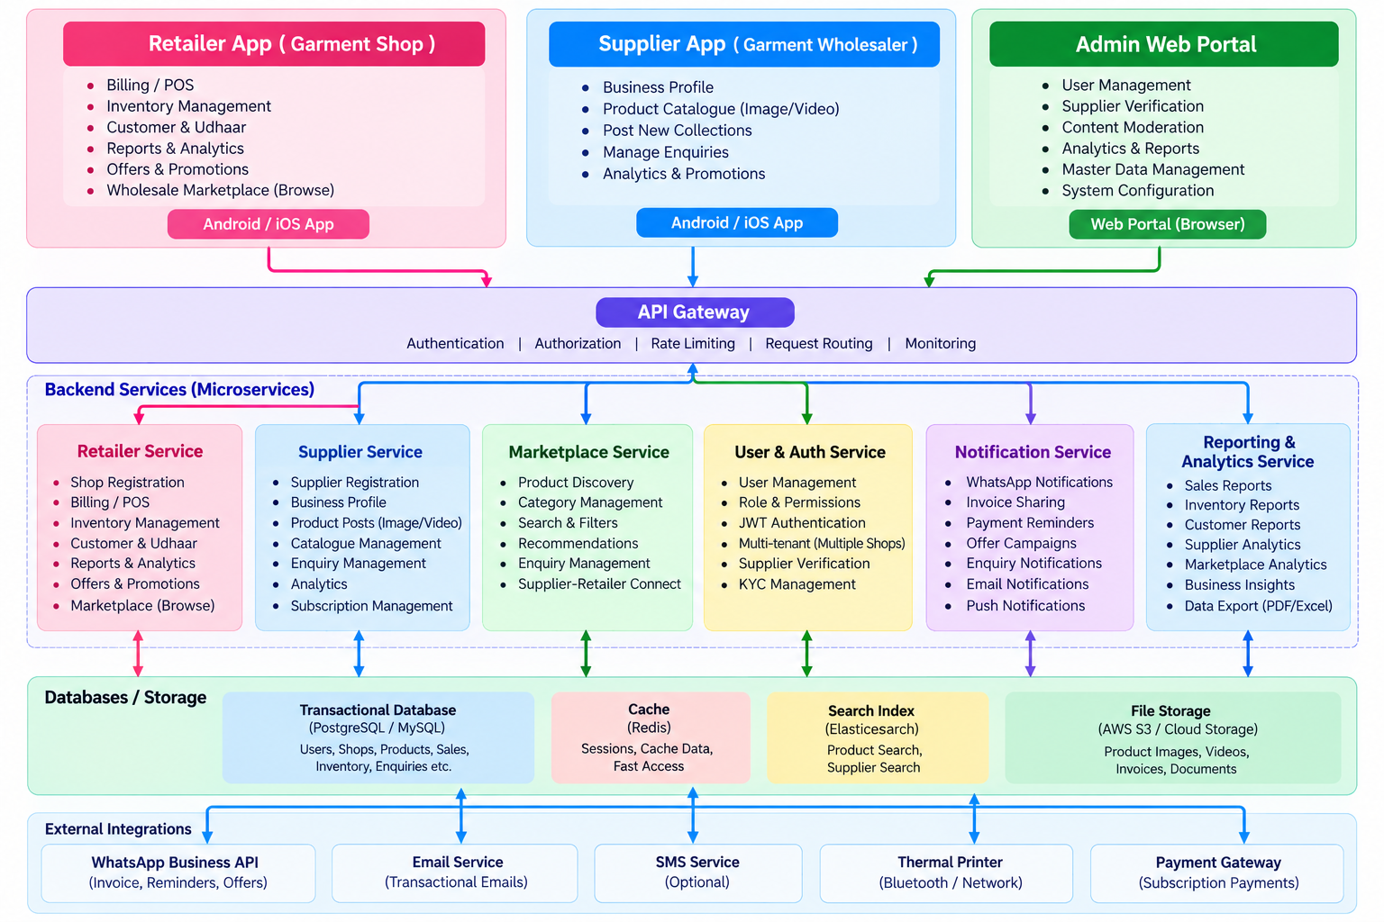
Conceptual architecture; implementation technology is finalized during technical design.

8. Core System Components
Component | Responsibility
Retailer Mobile App | Billing, products, inventory, customers, Udhaar, reports and marketplace discovery.
Supplier App / Portal | Supplier profile, product posts, catalogue, enquiries and analytics.
Platform Backend | Authentication, APIs, business rules, notifications, marketplace services and permissions.
Data Layer | Retailer business data, products, inventory, customers, suppliers and marketplace content.
Media Storage | Supplier product photos and videos.
Analytics Layer | Sales, inventory, demand and marketplace performance.
Admin / Operations | Supplier verification, content moderation, categories and support.

9. Marketplace Flywheel
- Retailers adopt the billing app because it solves a daily operational problem.
- The platform builds a growing network of active garment retailers.
- Wholesalers gain access to a concentrated audience of garment-shop owners.
- Suppliers publish new collections, images and videos.
- Retailers discover products and generate enquiries.
- Successful supplier engagement attracts more suppliers.
- A stronger marketplace gives retailers more reasons to remain on the platform.

10. Data-Driven Personalization
Over time, retailer-side product and sales activity can support better discovery, subject to appropriate permissions, privacy controls and aggregation. Examples include prioritizing categories a retailer frequently sells, highlighting relevant new arrivals, and surfacing products matching the retailer's business profile.

11. Monetization
- Retailer SaaS subscription.
- Supplier subscription / premium seller plans.
- Featured product placement.
- Sponsored supplier campaigns.
- Potential lead-generation or marketplace service fees in a later phase.

12. MVP Boundaries
Retailer MVP
- Billing
- Products with size/colour variants
- Inventory
- Customers
- Udhaar
- WhatsApp invoice
- Basic dashboard
- Basic reports
Marketplace MVP — later
- Supplier onboarding
- Supplier profile
- Image/video posts
- Retailer marketplace feed
- Product details
- Call / WhatsApp / enquiry
- Basic supplier enquiry dashboard

13. Long-Term Vision
The long-term product is not only a billing application. It is a digital operating and discovery platform for the garment retail ecosystem: retailers use it to run their shops, while suppliers use the retailer network to introduce new wholesale collections.
Positioning: “Run your garment shop. Discover new collections. Connect directly with wholesalers.”

14. Open Technical Questions
- Android-only initially or Android + iOS?
- Offline billing and synchronization strategy.
- Cloud backend and database selection.
- Thermal printer integration.
- WhatsApp integration and template requirements.
- Supplier video storage, compression and delivery architecture.
- Marketplace moderation and supplier verification.
- Search/recommendation architecture at scale.
- Privacy, consent and use of retailer analytics.
- Subscription and payment architecture.

